

**JDM Solutions Product Requirement Document**

| PM Author | Jeamelee Smith, Damian Hynes, Melvin Narayana & Derrick Logan |
| --- | --- |
| PM Reviewer(s) | Conrad Mathison & Pablo Pérez Villanueva |
| TL and UX co-owners |  |
| Last updated | July 29,2021 |
| Status | DRAFT / REVIEWED / LOCKED |
| Useful Links |  |

| [Review Deck](http://go/yourreviewdecklinkhere) | [UX Mocks](http://go/yourUXmocklinkhere) | [Engineering design doc](http://go/yourengineeringdesigndoclinkhere) | [Project Doc Repository](http://go/linktoprojectteamdrivehere) | [Meeting Notes](http://go/teameetingsordecisionloghere) | [Ariane](http://go/arianeentryhere) |
| --- | --- | --- | --- | --- | --- |

Abstract

[Press Release](https://docs.google.com/document/d/1o6QT1eyF-3pxehmj28z0G5nVxLVFzPUvIv6fH9LYiW4/edit#heading=h.upi3zxk2omaz)

Business Objective and Impact

User Journeys

Requirements

Non Goals

Success criteria

[Success Metrics](https://docs.google.com/document/d/1tH3RDR7wo7YzsrbfmpY-E6eUtjf51lOlu54xz9JfyvA/edit?ts=60f07e43#heading=h.yz8jijxji4mk)

Assumptions

Dependencies

i18n

Compliance and privacy

Accessibility

Support and tools

Open questions

Roll out plan

References

Revision History

# 

| Challenge | Opportunity (Solution) | Objective | Approach |
| --- | --- | --- | --- |
| The current data collection and entry process is not efficient to make future predictions/ projections. | 1. Supplier can predict future sales 2. They can measure their overall success rate in a shorter time period 3. Aid in company’s future budgeting and product planning | Our main objective is to make the data collection and entry process easier in order to measure the company’s growth rate. Also to make predictions/ projections. | 1. Gather merchandisers financial reports 2. Clean the data, in order to spot outliers 3. Analyze the data in order to gain insight of past events and why it happened 4. Design a system to automate reports 5. Visualized data to obtain a graphical view of reports 6. Use machine learning to predict future sale/ events 7. Then the company can prescribe measure to mitigate against future event that will negatively impact suppliers |

# **Abstract**

Company X. merchandisers currently use a manual system to move all their reports into one central location. The manual system makes it tedious to compile all the reports into a unified document. In solving this problem our JDM Solutions decided to implement an automated system for reports, to mitigate against errors and late submissions of reports. The new system will improve company efficiency and make timely decisions. We will design a dashboard to show the various reports we gather from the merchandiser, and use machine learning to make future decisions for the supplier.

# **Announcement to Customers**

The platform helps suppliers automatically update reports to their database. The automated system will assist suppliers with timely decisions on whether or not they need to replenish goods/ products, budgeting and projections. The solution also provides a dashboard, showing the various reports from the database system. The platform solution will assist suppliers with predicting future sales and events. We have provided a cloud base and a resident system for flexibility.

# **Business Objective and Impact**

The following questions (from “Assessing Product Opportunities” by Marty Cagan, 13 Dec 2006 <http://www.svproduct.com/assessing-product-opportunities/>) can be used to assess the opportunity:

1. Exactly what problem will this solve? (value proposition)

* Suppliers can automated their reports
* .Supplier can make future prediction/ projection seamlessly
* It also provides a graphical layout of product distribution and progression.

1. For whom do we solve that problem? (target market)

* Supermarket suppliers/ merchant

1. How big is the opportunity? (market size)

* 80 - 120

1. What alternatives are out there? (competitive landscape)

Making a list and informing them over telephone`

1. Why are we best suited to pursue this? (our differentiator)

We are best suited to pursue this because we are analytical thinkers with technical skill to bring this project to success. We understand agile project management and that it is critical when building platforms like these. Most importantly we are detail oriented and determined.

1. Why now? (market window)

Now is the best time for this innovation because everything is being digitized.

1. How will we get this product to market? (go-to-market strategy)

In getting our solution to the market we will use a subscription base model costing US$99 annually, in this offer suppliers will receive basic reporting and the importation of their excel sheets. However, if they need customized reports we will pay an additional US$49.

1. How will we measure success/make money from this product? (metrics/revenue strategy)

Our team aims to provide a more viable solution to suppliers. Suppliers are using a manual system to collect and enter data which they deem to be inefficient because it is a time consuming process. Providing automated data collection and entry processes may lessen the time it would normally take to go through this if used properly.

1. What factors are critical to success? (solution requirements)s

The involvement of the supplier/ merchant, along with the data being properly defined and the architecture of the platform solution.

1. Given the above, what’s the recommendation? (go or no-go)+
2. Press Release

[PRESS RELEASE](https://docs.google.com/document/d/1Wg4FtD7dH-LAOmrxzyvBNgfC0p-GjjDwOHjjV4dkbP8/edit#)

# **User Journeys**

Our platform solution was implemented to assist suppliers to improve employee efficiency. Suppliers hire several merchandisers to ensure supermarkets they supply are adequately stocked with their product. However, merchandisers are using a manual system to submit reports. The managers will later merge all the reports from various merchandisers into one central location. Managers use a manual system to analyze reports to make projections and to estimate future sales. Our team has discussed several solutions for this project. However, we have decided to work agile in assisting suppliers with employee efficiency. This will facilitate smooth transition rather than change their current system into a fully automated system. So, merchandisers will continue to submit the monthly excel sheets, these suppliers will merge these excel sheets into a central location. Then we will automate the process by importing the reports to a database system. This system will reduce human errors, late submission, etc., and facilitate a more efficient working environment. After which suppliers can view these from the dashboard connected to the database, they can also drill down into data seamlessly to see the progress of location, single products etc.. The solution lessens the workload giving employees more selfie time.

# **Version One**

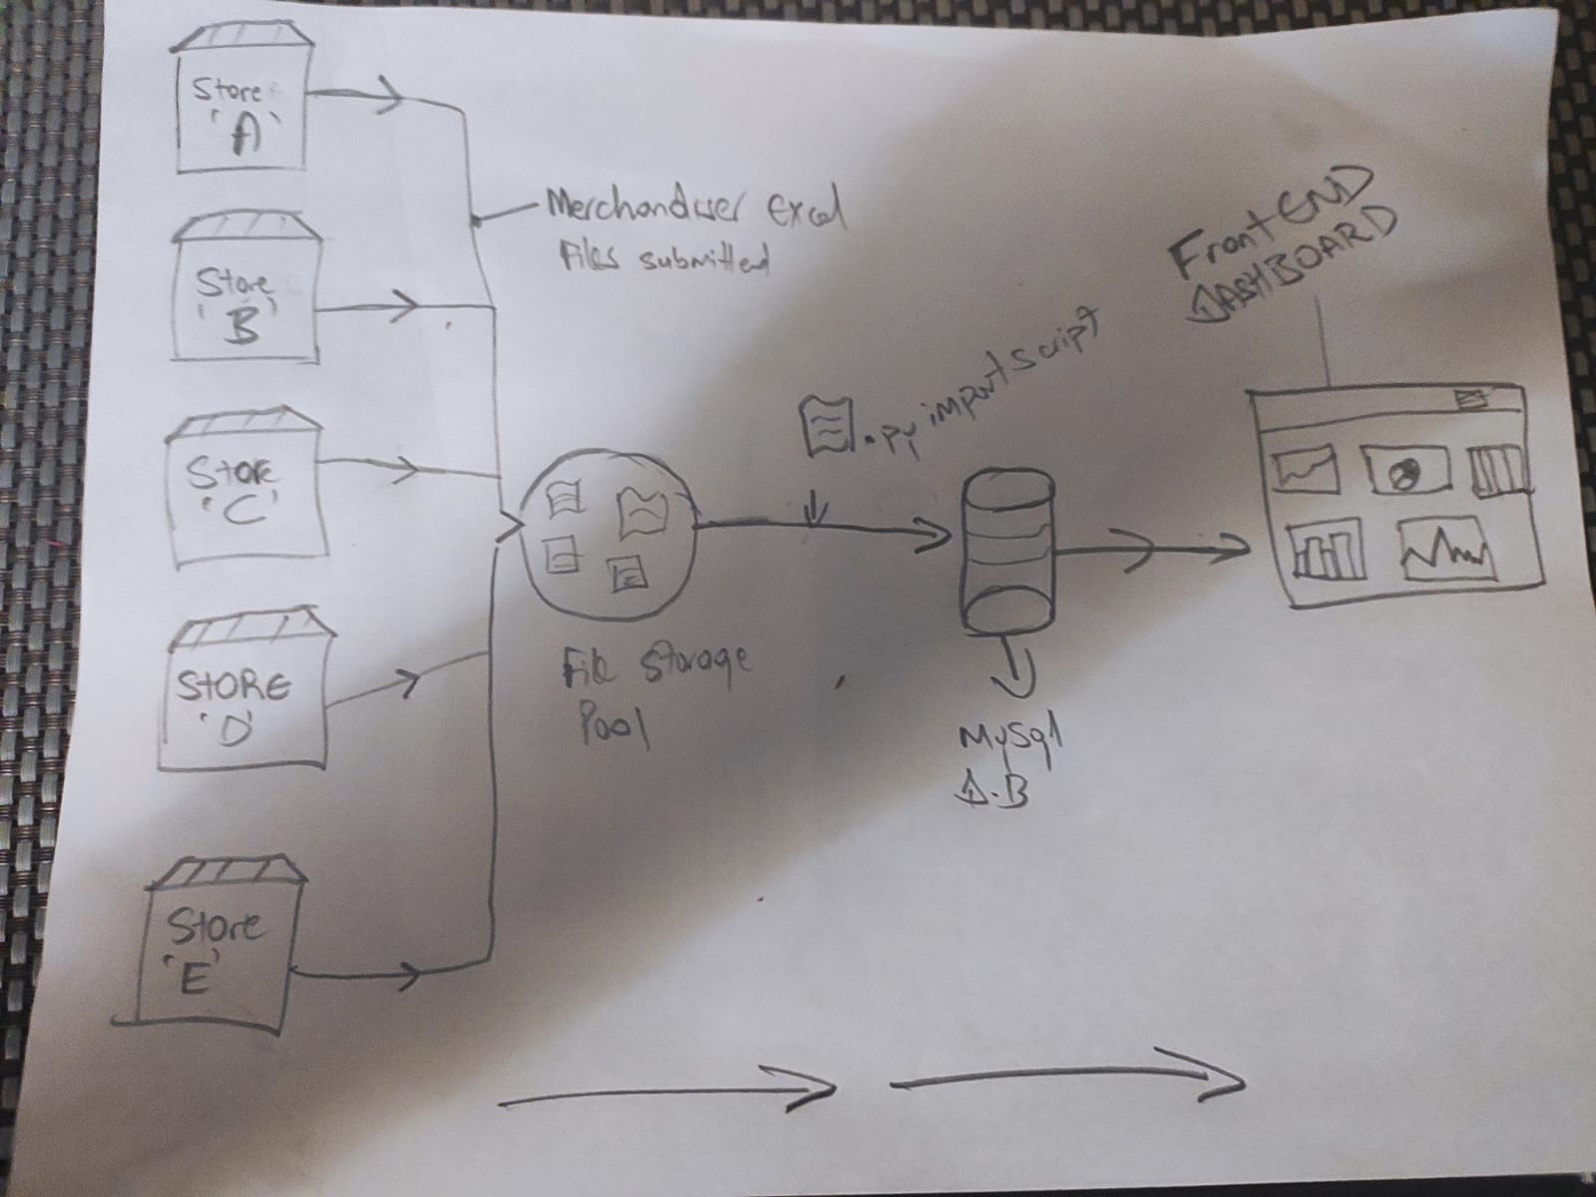

# **Version Two**

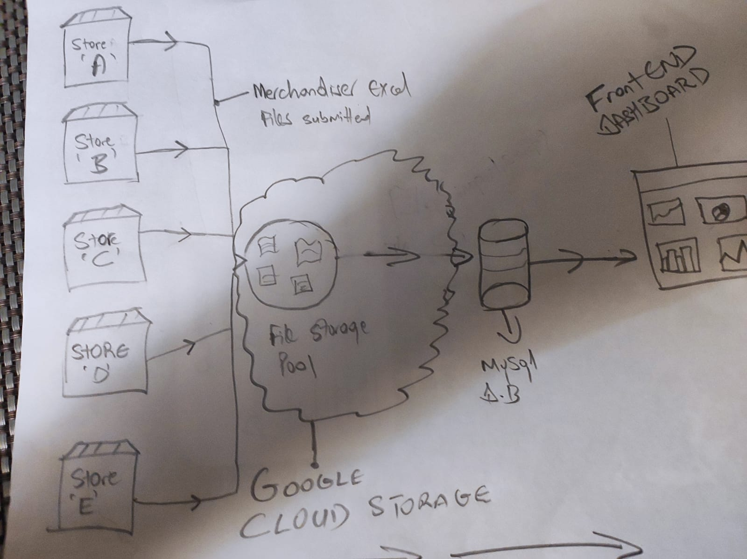

# **Version Two**

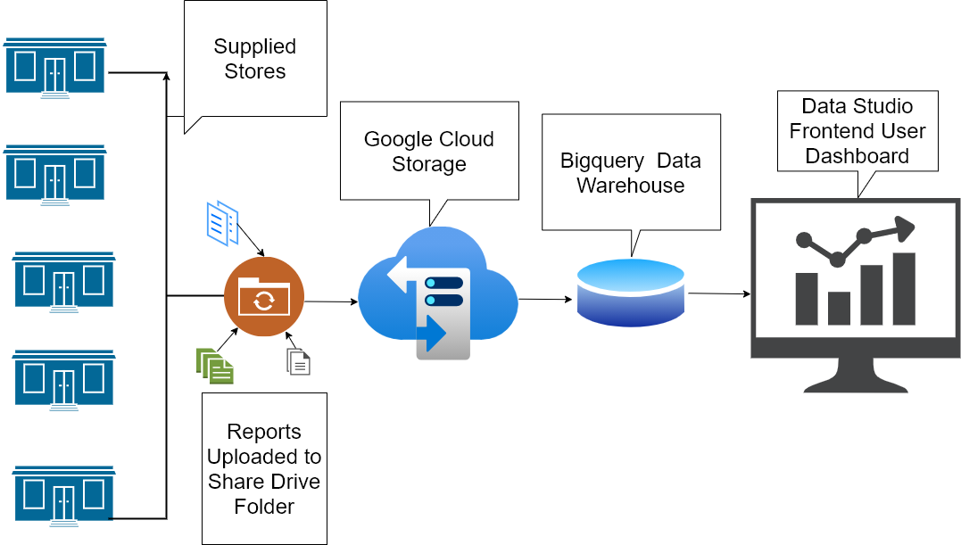

# **Requirements V1**

Test Plan :

Our main business goal is to provide the Suppliers with inventory data monthly from the Merchants in a timely manner.

The following order is prioritized according to the requirements needed:

1) Microsoft Excel : We start at the merchandiser who would bring their monthly reports to the suppliers and the suppliers would feed this data into Excel sheets and keep them in a storage area. This product helped us with populating raw data and performing calculations.

2)Python: Python scripts were used to import the data into MySQL in order to have a semi-automated process. Python is one of the open source programming languages that is most suited for data analytics.

3) MySQL: The Excel sheets that were stored, were used to import them into the database. A front-end dashboard was created to pull up several reports. This platform helped us with data security, performance and making vital decisions.

5) Github : This platform was used to host the project giving access to everyone. This data management platform enabled us to collaborate remotely using the online platform. It provides a clear and well-documented path for data analysis.

# **Requirements V2**

Test Plan:

Our main business goal is to provide the Suppliers with inventory data monthly from the Merchants in a timely manner in order to mitigate human errors, late submissions, etc.

The following order is prioritized according to the requirements needed:

1) Microsoft Excel : This product helped us to perform calculations and has the tools for data analysis. This product helped us with populating raw data for use in data analysis.

A Python script will open the Excel sheets from their locations and pull them into the database. The database link will be created for the excel file. The pivot tables are spun up in the Excel file displaying the data.

2) Python : This language was used to bring in the data scripts to the database using maching learning. This will be used for predictive analysis for the supplier and helps for future budgeting or how well an item is doing ? A python script was developed that runs against the storage pool and handles your data transformations and inserts them into the database.

3) BigQuery : We had initially planned to use MySQL as the database but later changed to BigQuery due to the fact that we wanted to move to a cloud based system to save costs as we planned to expand since the data here will be used for analytical purposes and predictions. This platform helps us to store the needed data to make vital decisions.

4) Google Data Studio : We have used this platform to deliver the reports since it connects to BigQuery. It is a free great data visualization tool that allows us to create interactive dashboards and beautiful customized reporting and allows for report sharing and scheduling. It can help transform reporting from a long, tedious task to a fast and easy one

5) Github : This platform was used to host the project giving access to everyone. This data management platform enabled us to collaborate remotely using the online platform. It provided a clear and well-documented path for data analysis.

Monetization considerations :

This product will be upgraded to a fully automated system and will be available on an annual subscription model which includes maintenance.

Data Handling:

Data will be stored physically also in the event of data wipeout or any type of disaster that involves environmental damages due to weather or power failure.

# **Non Goals**

For this project, we have decided to exclude the merchant portal for suppliers which creates a direct link between supplier and supermarket they supply. In particular, the supermarket inventory system provides instant access to the supplier Merchant Portal . This will help suppliers keep track of the daily flow of products.

# **Success criteria**

| Goal | Signal | Metrics | Target |
| --- | --- | --- | --- |
| System provides automated reports | Users are satisfied with the reports generated | % of reports completely satisfying requirements | 90% of reports satisfying requirements completely |
| System will generate projections seamlessly. | Prediction/projections generated enable key decisions | % of key decisions satisfied by prediction/projections | 70% key decisions satisfied. |
| Dashboard provides user information needs | Dashboard is easy to use and provide useful information | User satisfaction with dashboard. | 80% user satisfaction |
| Database provides data to satisfy user demands | Reports, projections, dashboard requirements are satisfied | % of data requirements met. | 70% of the data required found in database |

We have decided to use the Agile Methodology that stresses cross-functional collaboration, adaptive planning, early delivery, and continuous improvement. This is highly encouraged as it will make feedback, transparency and collaboration the key in the success criteria of this product.

# **Assumptions**

* For this project, the subsequent assumptions were made; for V2 we are using google cloud storage to store all the reports from the various merchandisers in a central location. However, the google cloud store is not free; we assume we have full access to the paid version in order to store all the reports.
* We are also using that both versions will have consistent data across the various stores for the merging process.
* V2 will be fully cloud-based; so, we assume they will have internet connectivity whenever it's time to be used.

# **Dependencies**

For the success of this project, we are mainly relying on the full participation of our team members. It will assist us in balancing the workload to complete the project, as we are working with a time limit. Data plays a crucial role in the success of this project. We used data to design dashboards, and from this dashboard, the supplier can make various decisions. We rely on the functionality of the different tools to carry out all functions required for this project. Specifically, V2 will depend on the paid version of the google cloud storage to merge the reports in a central location.

# **i18n**

None for the initial version of the system.

Subsequent versions will include multi-currency and language capability for Spanish and French to take care of expansion into the Latin American and Caribbean regions. Expansion outside of Jamaica will necessitate cloud solutions as the application is scaled to meet requirements.

# **Compliance and privacy**

The data we will be operating on does not have any privacy or legal dimensions that must be considered, however looking into the fact that data from one supplier should be kept private from the other supplier and that sufficient direct and indirect access to relevant sources of data to allow for timely and effective tracking and monitoring of data is vital to us so that we don't misinterpret data, avoid data loss, corruption and misuse

# **Accessibility**

In designing our platform solution our team ensures to carefully consider our user, therefore, users with specific disabilities can contribute and use our platform. They are:

* We going offer our platform uses different languages
* We are going moderate font sizes
* We have two versions of our platforms, version one can be used for resident data and suppliers can use version 2 for storing data in the cloud.

# **Support and tools V1**

The Customer will be the supplier who will be using the data taken from the Microsoft Excel connected to the database using MySQL to make vital decisions based on performance of the product, store performance, progress of location, etc.. This will help reduce the workload and improve efficiency.

# **Support and tools V2**

The Customer will be the supplier who will be using the data taken from the Google data studio cloud platform connected to the database using BigQuery to make vital decisions based on performance of the product, store performance, progress of location, etc.. This will help reduce the workload and improve efficiency.

# **Open questions**

1. What is the nature of the projections that the supplier needs?
2. What granularity is required? E.g. monthly vs quarterly, item category vs item.
3. What google tools will be required e.g. cloud storage, Data studio, automl.
4. Details of monetizing arrangements. Subscription vs one time payment etc.

# **Roll out plan**

[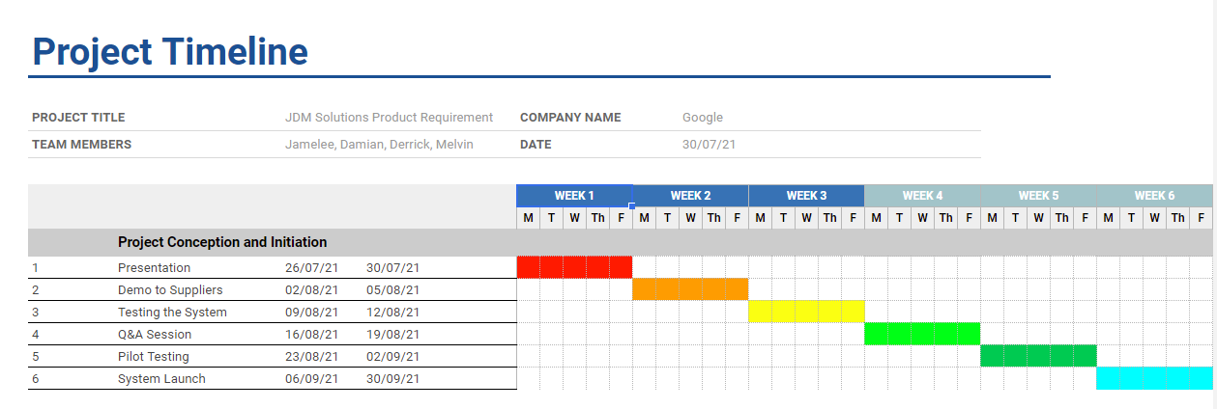](https://docs.google.com/spreadsheets/d/1jHD4sc-B04CN4O5mrTUEVEafylXBtju_gmRwHji1_Lk/edit?usp=sharing)

Measurements to find out if a feature is performing as expected will be done during the testing phase of the project. A Rollback plan will be looked into after a couple of months or years if it fails to meet the intended goals and appropriate actions will be taken into consideration.

# **References**

Key Contacts: Conrad Mathison & Pablo Pérez Villanueva

Documentation:

Bhandari, A. (2020, May 20). *New to Git and GitHub? This Essential Beginners Guide is for you*. Analytics Vidhya. <https://www.analyticsvidhya.com/blog/2020/05/git-github-essential-guide-beginners/>

Cagan, M. (2021, April 27). *Product vs. Project Teams*. Silicon Valley Product Group. <https://svpg.com/insights/product/product-leadership/>

Nasoi, R. (2019, April 2). *6 User Journey Mapping Examples: How UX Pros Do It*. CXL. <https://cxl.com/blog/customer-journey-mapping-examples/>

Novet, J. (2014, April 1). *Data scientists need their own GitHub. Here are four of the best options*. VentureBeat. <https://venturebeat.com/2014/04/01/data-scientists-need-their-own-github-here-are-four-of-the-best/>

Ruzicka, W. (2021, July 20). *How to Measure the Success of Your Analytics Projects*. DZone. <https://dzone.com/articles/how-to-measure-the-success-of-your-analytics-proje>

THE A11Y PROJECT. (n.d.). Introduction to Web Accessibility. Introduction to Web Accessibility. Retrieved July 22, 2021, from <https://www.a11yproject.com/resources/introduction-to-web-accessibility/>

Weinstein, R. (1999). How to write an abstract and present it at the annual meeting. *How to Write an Abstract and Present It at the Annual Meeting*, 195–199. <https://onlinelibrary.wiley.com/doi/10.1002/%28SICI%291098-1101%281999%2914%3A4%3C195%3A%3AAID-JCA10%3E3.0.CO%3B2-R>

Vickery, R. (2019, July 26). *Top highlight Introduction to Github for Data Scientists*. Towards Data Science. <https://towardsdatascience.com/introduction-to-github-for-data-scientists-2cf8b9b25fba>

Windsor.ai. (2020, July 31). *What is Google Data Studio and what are its benefits*. <https://www.windsor.ai/what-is-google-data-studio-and-what-are-its-benefits/>

Project Tracking: [SCRUM FRAMEWORK](https://docs.google.com/spreadsheets/d/1J-xHC_s7dEIRdM92BTi3SHVhfF6ItqiUHUPMfhgEaAg/edit#gid=0)

# **Revision History**

| Date | Notes |
| --- | --- |
| 18/07/2021 | 1. Finalized design draft Project 2. [First Meeting Minutes](https://docs.google.com/document/d/1EluPXSc8bKN8Xq2yAz2RERR910gUEoGgb4UZqSussUE/edit) |
| 19/07/2021 | 1. Complete section 1-3 of the PRD 2. Data Collection |
| 20/07/2021 | 1. Complete 4 -15 of the PRD |
| 21/07/2021 | 1. Importation of excel sheets 2. [Second Meeting Minutes](https://docs.google.com/document/d/1rNJd3LVvoxYIWSvmj_7cuoWm8lXyJF5DL07ELmwOP5s/edit) |
| 23/07/2021 | 1. Design dashboards |
| 27/07/2021 | 1. Complete V1 2. [Third Meeting Minutes](https://docs.google.com/document/d/1GQiENYtWCNuVoNp__ekAe_Od7z1WW6FcHWe5IzH9-Gs/edit) 3. Start V2 - Cloud base version |
| 28/07/2021 | 1. Complete PRD 2. Bigquery importation 3. Design Dashboard |
| 29/07/2021 | 1. Adjustment Charts 2. Complete V2 |